In order to create shopping cart functionality for our bookstore we first had to create the database and set-up the required tables for customers to make purchases. We did this by doing the using the following SQL statement:

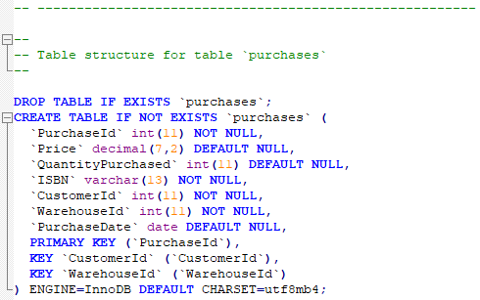

This table is crucial to our shopping cart functionality that will be implemented onto the webpage. This table will allow customers to be able to click onto an available book on our webpage and it will add directly to their “shopping cart”. In our case, it has been named “purchases”. In order to show that our shopping cart is working correctly, we have added example data into “purchases” table. This is shown in the following SQL data dump:

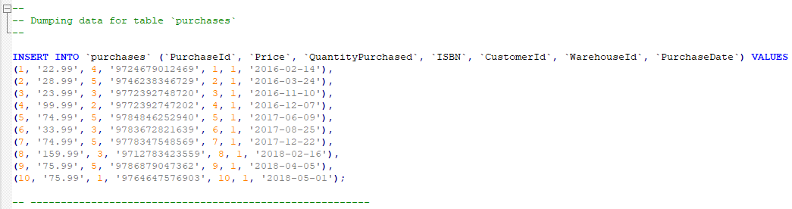

As mentioned before, once the customer decides what book they want to buy, a query identical to the one above will run and will add a new record in the “purchases” table relating the chosen book, customer ID and all other fields mentioned in “purchases” table. When the customer decides to click onto their shopping cart, the webpage will run the query that shows the customer that is logged in, their current purchases that they are about to make.

In PHPMyAdmin, this is what the purchases table structure looks like:

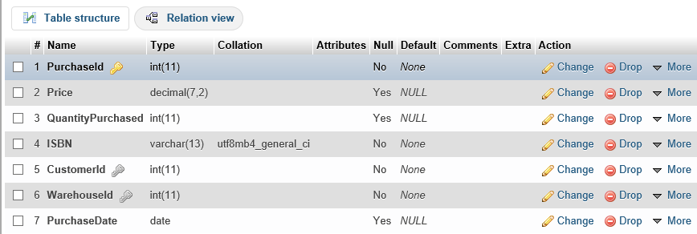

So, when the customer clicks on the shopping cart option on the webpage. The webpage will run the following SQL query:

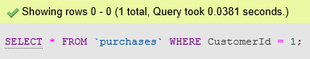

In this example, the “CustomerId” field will be updated according to what actual user is currently signed in by checking the “accounts” table and collecting their customer Id from there. Here is the outcome of the previous query that was run:



From here, the customer will be able to see all of the purchases that they have chosen in their shopping cart. Along with this, the customer’s details will be shown on screen in an additional query to confirm that these are the correct details of the customer before the book is forwarded to the delivery stage:

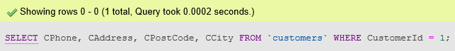

Just as last time, the Customer Id will change depending on who is logged into the webpage in the current session. Here is the outcome of this query:



Here is some example of what PHP code would have been used on our webpage.

The shopping cart javascript:

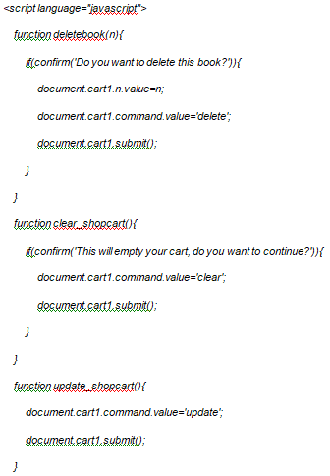

This code would have been used for additional functionality on the shopping cart webpage. It would have allowed the customer to be able to:

* Delete books from shopping cart,
* Clear shopping cart,
* Update shopping cart.

Another major piece of code that would have provided the layout of the webpage is the following CSS code on the next page:

*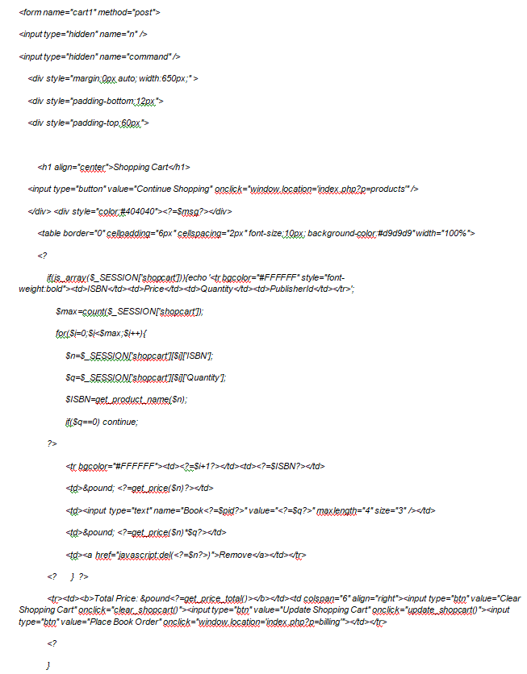 *

*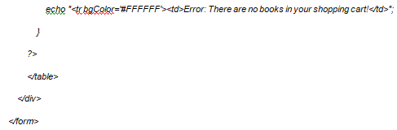*

This section of PHP code would have allowed me to add the following functionality to our webpage:

* Continue shopping button,
* Shopping cart form,
* Place Order.

The actual layout of our overall ecommerce functionality webpage will be explained in the storyboard document and video attached to the submission.